Poisson Homework
- Accidents occur on a certain stretch of motorway at the rate of three per month.
Find the probability that on a given month there will be …
a) … no accidents.
b) … one accident.
c) … two accidents.
d) … three accidents.
e) … four accidents.

- Cretan Airlines services which arrive late to Athens Airport on a typical week can be modelled by a Poisson distribution with mean of 4.5 .
a) Determine the probability that on a given week there will be …
  - four late arrivals.
  - less than four late arrivals.
  - at least seven late arrivals.
b) Determine the probability that on a given two week period there will be between eight and thirteen (inclusive) late arrivals.
3. A discrete random variable X has Poisson distribution with mean λ.
Given that P(X = 8)= P( X = 9), determine the value of P (4 < X ≤ 10).
4. The number of houses sold by an estate agent follows a Poisson
distribution, with a mean of 2.5 houses per week.
- Find the probability that in the next four weeks the estate agent
sells …
i. … exactly 4 houses
ii. … more than 6 houses.
The estate agent monitors the house sales in periods of 4 weeks.
b) Find the probability that in the next twelve of those four-week periods there are exactly 7 four week periods in which more than 6 houses are sold.
5. 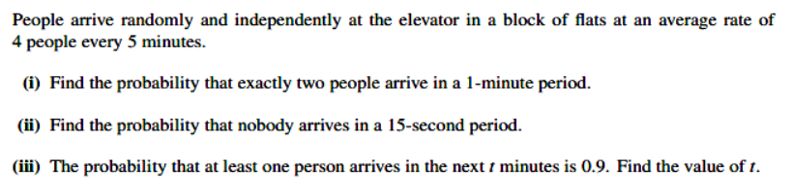

6. 